

**UNIVERSITY OF PETROLEUM & ENERGY STUDIES**

**Dehradun**

**CONTINOUS INTEGRATION**

**AND**

**CONTINOUS DELIVERY**

**Experiment**

**Name: Rithik Choudhary**

**Course: B. TECH CSE DevOps (2018-22)**

**Roll no.: R171218084**

**Sapid: 500069261**

**Experiment-13**

**Docker**

**Step-1:**  To find an image for Redis, you would use docker search redis. Docker will run a command in the foreground. To run in the background, the option -d needs to be specified.

docker run -d redis

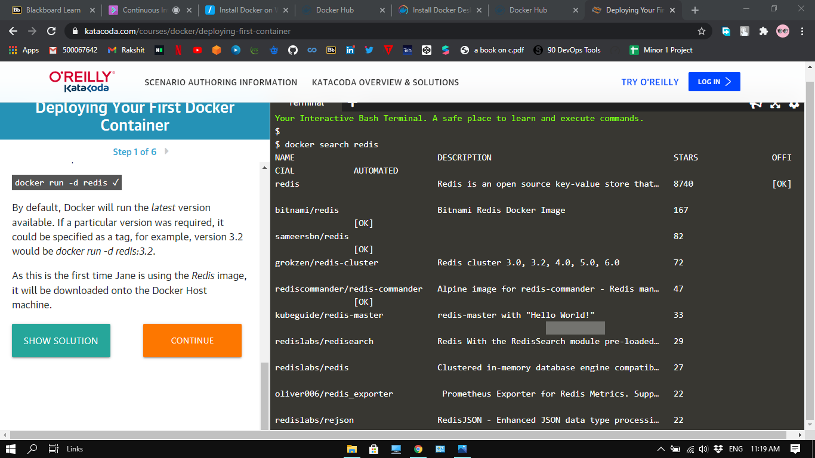

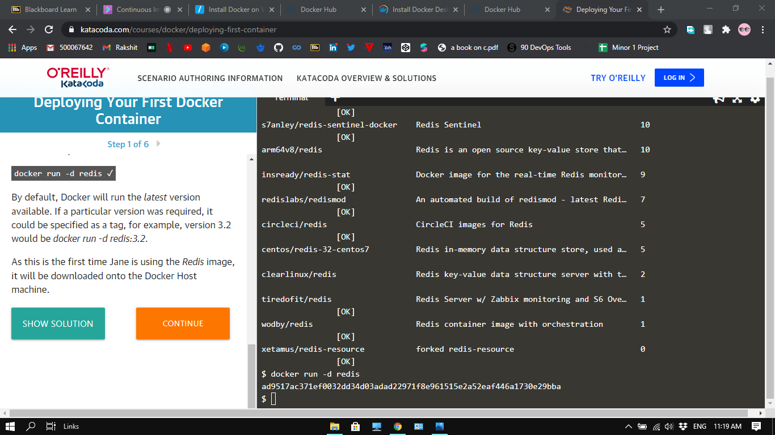

**Step-2:** The launched container is running in the background, the docker ps command lists all running containers, the image used to start the container and uptime.

The command docker inspect <friendly-name|container-id> provides more details about a running container, such as IP address.

The command docker logs <friendly-name|container-id> will display messages the container has written to standard error or standard out

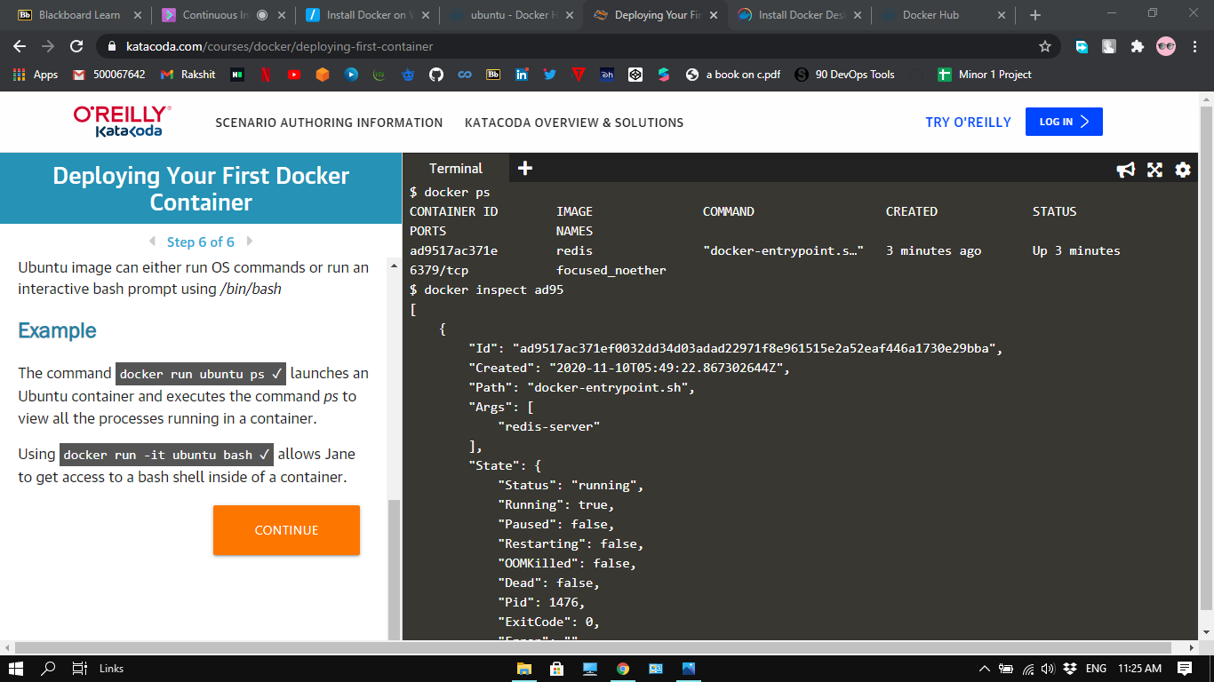

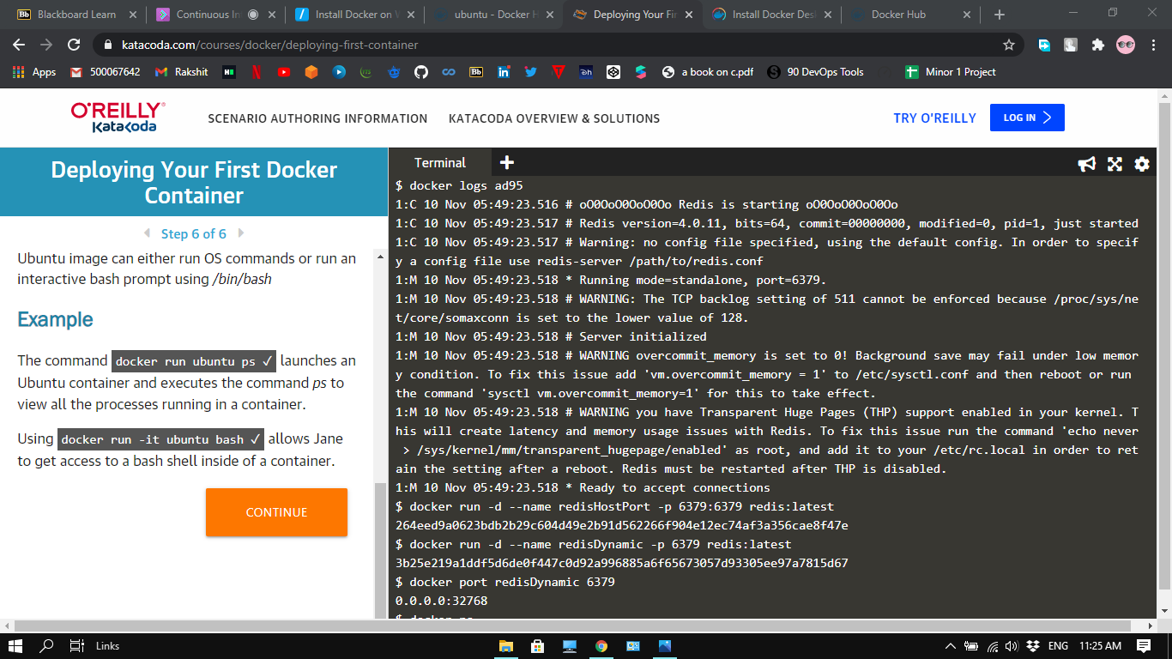

**Step-3:**  the best way to solve problem of running Redis in the background, with a name of redisHostPort on port 6379 is using the following command

docker run -d --name redisHostPort -p 6379:6379 redis:latest



**Step-4:**



**Step-5:**

